**Network Fundamentals Lecture 7 Notes**

**Media Selection**

Import aspects to think about when selecting the correct media are;

* Maximum data rates that can be supported
* Maximum length of a single cable run
* Susceptibility to electrical interference
* Major cost components that are associated with the medium
* Infrastructure constraints

**Media type**

**Data rate**

**Distance**

**Interference**

**Cost issues**

Radio-based wireless LAN

Typically up to 11 Mbit/s (some higher 54 Mbit/s)

Up to 50m indoors 205m outdoors

Some interference is possible

NIC plus access point cost is item

UTP

Up to 1 Gbit/s

Up to 100m

Some interference is possible

Labour cost is major item

Multimode fibre

Up to 1 Gbit/s

Up to 2Km at 100Mbit/s and 500m at 1Gbit/s

No interference problems

Labour cost plus expensive electro-optical

Single-mode fibre

Up to 10 Gbit/s

Up to 40km

No interference problems

Labour costs plus expensive electro-optical and high-power laser

**Dial-up telephone links**

* Dial up telephone links are available in two forms
* - Analogue (mostly legacy but not in all countries)
* -Digital
* Analogue telephone links require a digital-to-analogue modem card
* -Your PC provides a digital signal which is converted to analogue
* Digital links require a digital-to-digital adapter card
* -The digital signal from your PC is converted to an alternative digital form

Dial up telephone links



**Modulation**

* Modulation converts a digital signal into an analogue signal
* -This converted signal is sent across the analogue line
* Demodulation converts the signal back to digital
* MODEM
* -Modulation-DEModulation

**Modem**

**Digital**

**Analogue**

* Modems are standardized by ITU-T, V-series recommendations
* Typical modems include;
* -V.34 at 28.8kbit/s and 33.6kbit/s
* -V.90 at somewhat less than 56kbit/s
* -V.92 for higher-speed uplink, faster connection time, and the ability to accept an incoming call
* The data rate may fall back to lower rates
* -The modem will operate at the highest available dial up line
* May perform V.42 error correction
* V.42bis (4:1) or V.44(6:1) data compression
* V.54 loopback testing
* V.250 command set

**Connection Interfaces**

**RS-232 Interface**

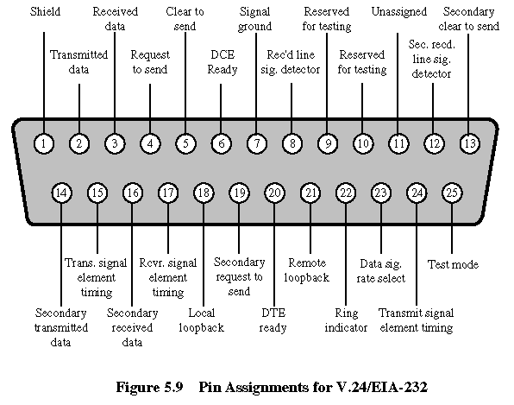

**Reasons for going digital**

* Computer data is inherently digital
* -Adapt more easily to digital transmission
* Higher data rates are available
* Easier to switch
* Better error rate
* -Noise is not cumulative, because repeats can reject induced noise
* -Amplifiers also amply the noise

**Digital voice channel**

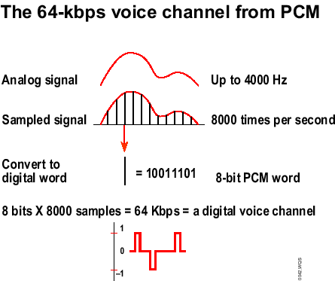

**Digital telephone channels**

* Digital telephone communications channels are also available;
* -56 or 64 kb/ps channels
* -1.544mbit/s (US, Canada and Japan 2.048mbit/s channels)
* Instead of modems, data services unit/channel services unit (DSU/CSU) adapter devices may be needed
* -The DSU adapts the digital signal (transmit and receive voltages and timing)
* -The CSU normalizes voltage levels, provides maintenance capabilities, and protects the public network

**The V.35 Interface**

* The V.35 interface is often used for higher speed DSU/CSU’s

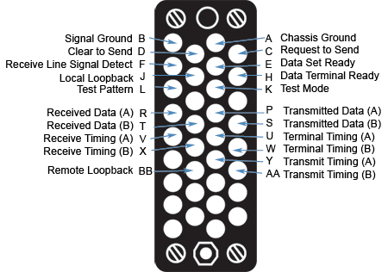

* V.35 has two-wire circuits for data and timing
* -Balance lines
* Contrast this with RS 232 one-wire circuits
* -Unbalanced (used on CISCO routers)
* The problem is that the V.35 interface can be put in the wrong way round unlike the RS 232.

**X.21 and Other Serial I/O Interfaces**

* A popular serial I/O interface is X.21 (Europe)
* -Reduce number of pins (15 pin connector)
* -Has transmit and receive pairs (for data and encoded commands)
* -Input and output control pairs (to indicate whether the transmit and receive are currently handling data or control)
* -Timing signal pair
* Networking devices typically support many different serial I/O standards
* -Usually with a common connector on the I/O module
* -Separate adapter cable for each different type of serial I/O standard (e.g. RS 232, RS 449, V.24 or X.21)

**Data Throughput**

**Problem with T1/E1 and T3/E3 Systems**

* There are several problems with traditional T1/E1 systems
* -T1 (North America and Japan) and the E1 (the rest of the world) are incompatible
* -It is very complicated to add or drop one 64 kbit/s channel
* -There is little problem isolation information in these system
* -There is a need for higher bandwidth
* A new system is needed
* -This is SONET/SDH

**Fractional and Full T1/E1 and T3/E3 Links**

* Fractional T1/E1 links are multiples of 64 kbit/s
* -A common example is 384kbp/s 6X64kpb/s
* -Used with video conferencing
* Fractional T1 may also be in multiples of 56 kbit/s
* Full T1/E1 is one of the most common types of WAN links
* -T1 = 1.544Mbit/s (24 slots @364kbit/s + 1-bit framing)
* -E1 = 2.048Mbit/s (32 slots @364kbit/s including framing)
* Sharing a communication circuit in this manner is called time-division multiplexing
* T3 channel is 28 T1 channels multiplexed together
* -T3 is approximately 45Mbit/s
* An E3 channel is 16 channels
* -E3 is approximately 34Mbit/s

**SONET and SDH**

* Two different forms of high-speed synchronous optical networking standards have been developed
* -Synchronous Optical Network (SONET) is a North American standard
* -Synchronous Digital Hierarchy (SDH) is an international standard
* The principle difference is the data rates
* -Multiples of 51.84Mbit/s for SONET
* -Multiples of 155 Mbit/s for SDH

**SONET/SDH Rings**

* A very resilient form of SONET / SDH is a dual ring
* -Automatically wraps to use both rings when cut
* -Recovery is within 50msec

